
Procedure 2025

ArcelorMittal Building Solutions France Procedure 1.1.1.2

ESCOMPTE RDU

Processing :
- The 2nd or 3rd for the close of the previous month
- Between the 12th and the 15th
- Around the 25th
- At the Credit Manager's request

Table of contents
- SAP extraction 3
- Excel table 6
- Validation of assets 8
- Discount credit note lettering 10
- Ranking 10

SAP extraction

On the SAP application, select "ECC Unity Production", then log in with your account id:
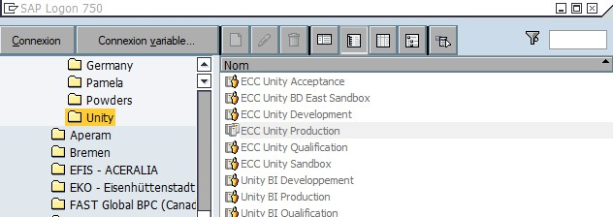
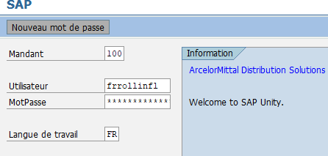

Go to Accounts Receivable => Account => Individual Customer Pos.
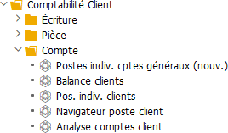

Tip: for easy access, you can also bookmark the most frequently used accounts: left-click on the line you wish to bookmark, then release the bookmark button.


Select transaction FBL5N :
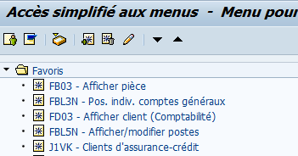

Then fill in the following data:
- Company: FR01
- Open items: current date or as at 30/31 for month-end closing
- Category: check "standard stations" only
- Layout: /FR01 RDU 2

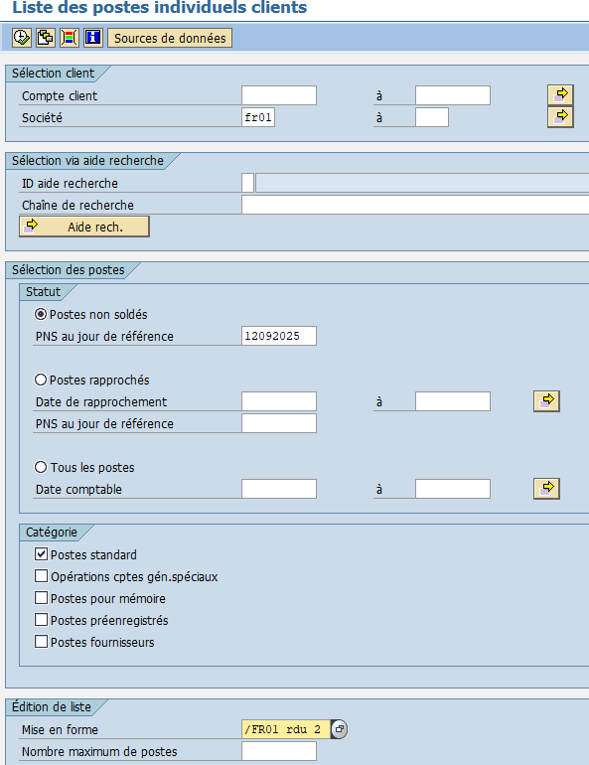


è Execute (F8)

Once the list has been loaded via SAP, open it in Excel :
- List tab / Export / Spreadsheet...
- Extract document to desktop
- Save it in: K:/ Customer credit / RDU discount / Year / File name: RDU at YYYY/MM/DD
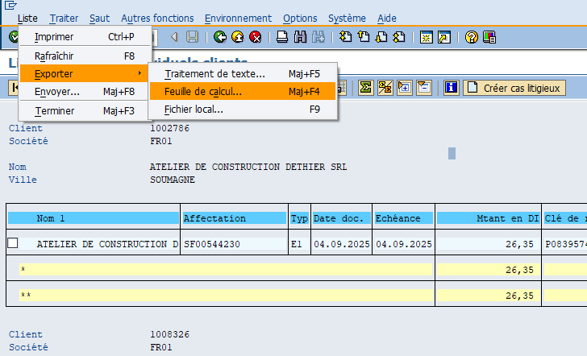

An SAP GUI Security window will appear. Simply click on Authorize.

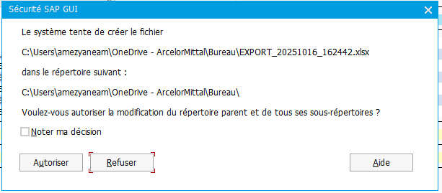

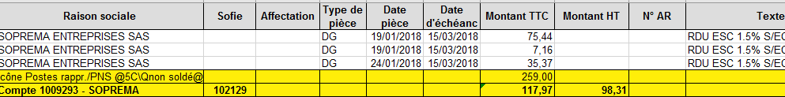
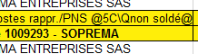
- Excel table

Table layout :
  - Remove duplicate lines from subtotals
  - Add two columns: pre-tax amount and Sofie code
  - Copy the first row of the previous table and paste it into the new table to take over the column headings.
  - Enter the company name next to the SAP number, in the yellow subtotal line.
  - Use the sum formula for subtotals by customer for VAT including + formula for calculating the amount excluding VAT
  - From the old file, search for the account number (e.g. 1009293), to find the Sofie code, and put it back in the new table, or search for it in SAP directly (once on the customer file, click on this icon the Sofie code appears in the "Anc. Account no." in "Reference data" → )

=sum(G2:G4) =G5/1.2

Once you have done all the necessary for each customer, calculate the total including VAT (sum of all the subtotals for each customer) by dividing by 2 (since otherwise you will have the total of the rows but also the totals for each customer), then calculate the amount excluding VAT at the bottom of the table:

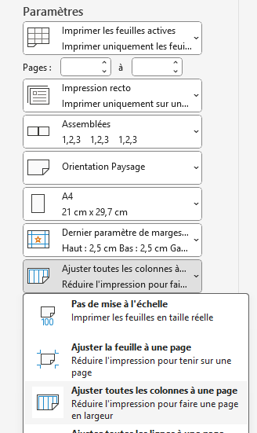
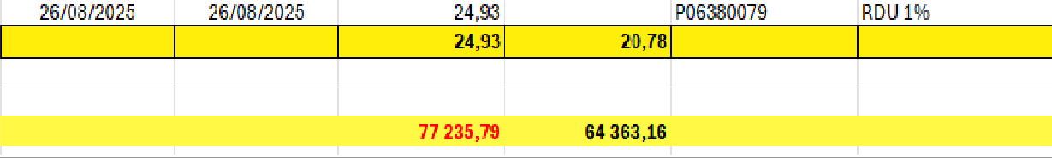

Operation to be performed :
In column I, next to each subtotal by customer, note the operation to be carried out in order to balance the remaining discount deduction:
- Amount incl. VAT > €60: CREDIT NOTE TO BE ISSUED (to be settled by a manual credit note issued by us)
- Amount incl. VAT < €60: OD TO BE PASSED (SSF will enter an accounting transaction)
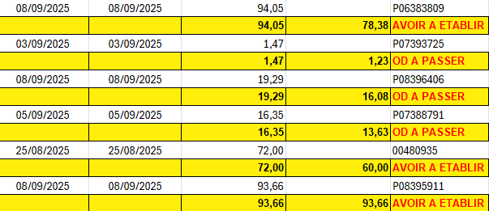

Prepare the table layout :
- Settings: Landscape orientation & adjust all columns to one page
- Layout: Header / Custom header: Name the document
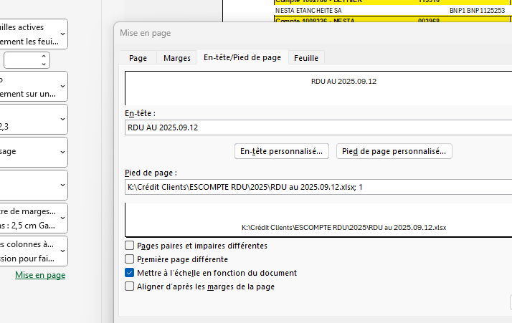
Footer: document path in the middle, page number on the right

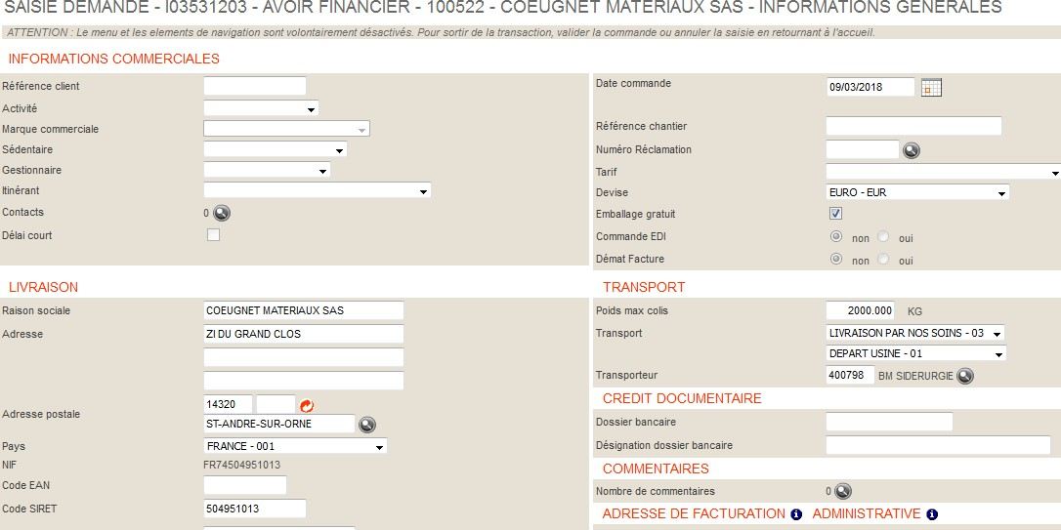

ESCOMPTE
ENTREPRISE CONSTRUCTION DISTRIBUTION GALVA
Always NO for RDUs

Credit validation
Save and forward to manager for approval

Once the Credit Manager has validated the discount table, credit notes must be issued to balance the discount deductions in the various accounts.

Go to the Premium Account application and select "Manual invoicing".

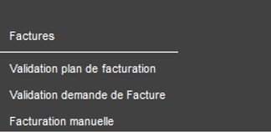

- Select "Financial credit" and fill in the customer code (Sofie code), then validate
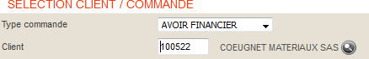
- Fill in the customer reference, the activity, uncheck EDI + dematerialization and add a comment
(if entry is blocked for EDI/dematerialization, enter password at bottom right)

- Enter the discount credit comment and validate:

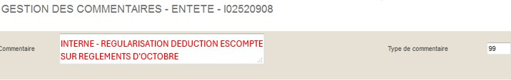

- Close the window, click on " Access the entries " and complete as below:
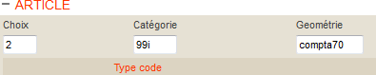

Then click on "Add":


- Fill in the quantity "1" and the amount (excl. VAT) in the "Price (EUR) Amount" column:
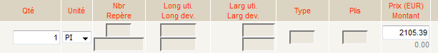

Validate items

- Summary: always check that the amount shown in the RDU table is exclusive of tax + VAT = inclusive of tax
(check currency)
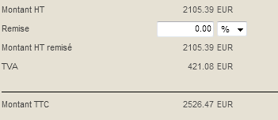

Then validate
è Print credit note

Lettering of discount credit notes

Send an e-mail the next day to the accounting department to have the RDUs lettered and the ODs entered, attaching the discount table (validated credit notes will not appear in the account until the following day).
The email should be filed in the Haironville Accounts Receivable inbox, under the folder “6) RDU DISCOUNT.”

Filing

The table and the credit notes should be stapled together in descending order and must be signed by the head of customer credit and management control (last printed page of the discount table).
store in the credit/bill file with a post-it note on the right, labelled "RDU + date", so that you can find all your invoices

On: 16/10/2025
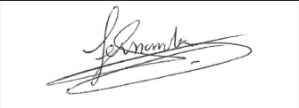
Procedure validated by : S. HERNANDEZ

